What You Will Learn
- What investment products are available to invest our money in?
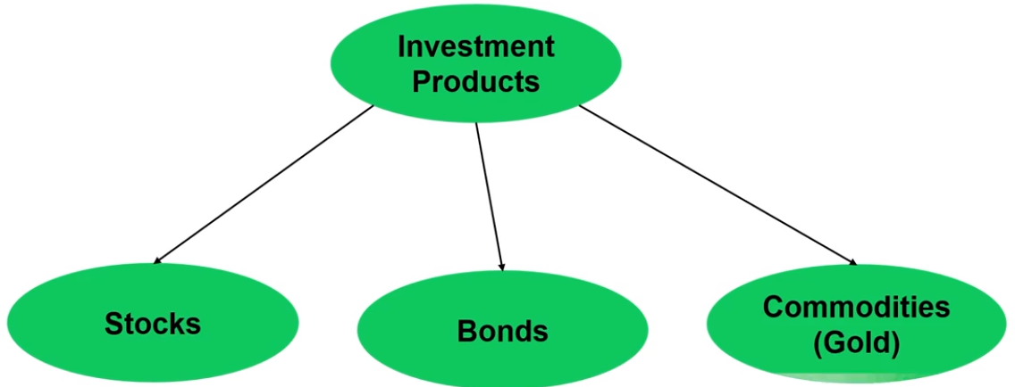

- How will I invest in these investment products?
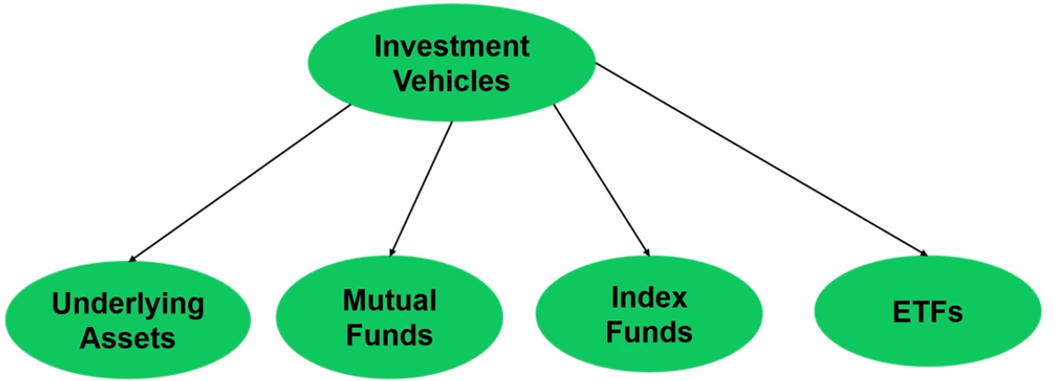

- How will I divide and monitor my investments among these investment products?
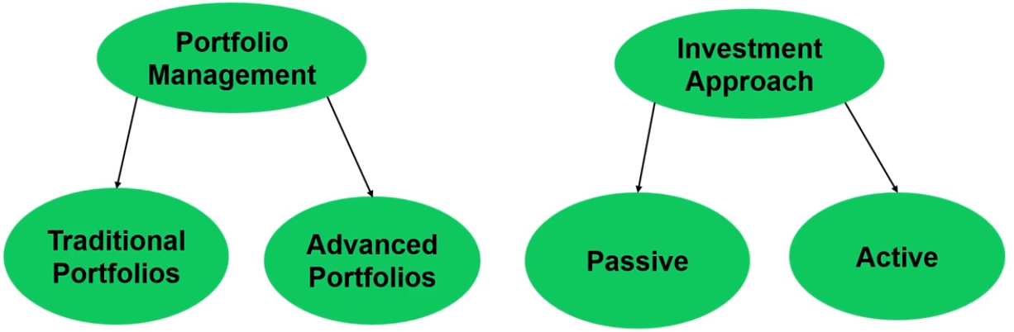

Why Should We Invest?
- Cash loses money over time due to inflation.
- Grow your wealth / net worth.
- Retire early since investments can make you a profit bigger than your salary! For example, if you are willing to work for 40 years, if you save only 15% of your annual income for investments, by the time you retire, you will have made more money from investments than your job!
- Retire with a lot of money to enjoy life.

